3.1 Authentication & User Authorization
Authentication is implemented with JWT bearer tokens to secure system access across all client applications. The involved classes and components are: AuthController (exposing the POST /api/auth/login endpoint with the AuthPolicy rate limiter), AccountRepository (retrieving account credentials and status), BCrypt.Net (verifying hashed passwords with a constant-time dummy hash fallback to prevent username enumeration timing attacks), RoleRepository (resolving role-based authorization claims), UserProfileRepository (retrieving the user's full name and personal metadata), and ITokenService / TokenService (generating signed JWT access tokens containing user claims). On the presentation tier, login.jsx submits user credentials, captures the returned AuthResponse, persists the JWT token and profile to localStorage, and updates the React authentication context before redirecting to the role-specific dashboard.

3.1.1 Class Diagram
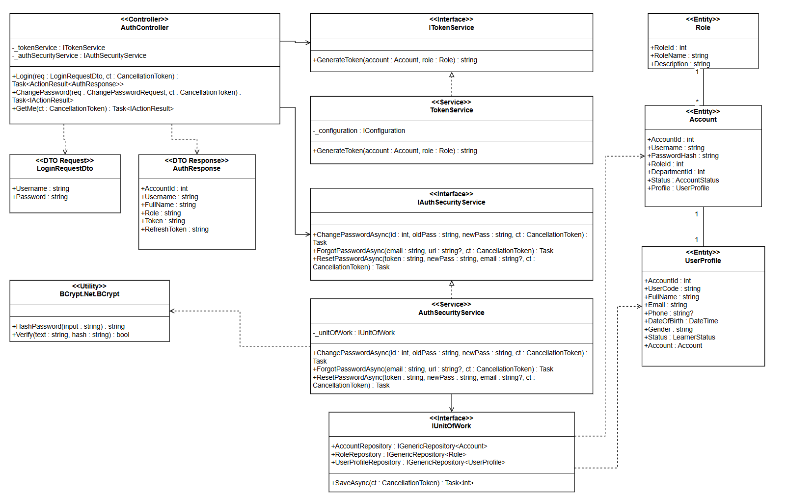
Image 64. Class Diagram – Authentication & User Authorization

3.1.2 Sequence Diagram
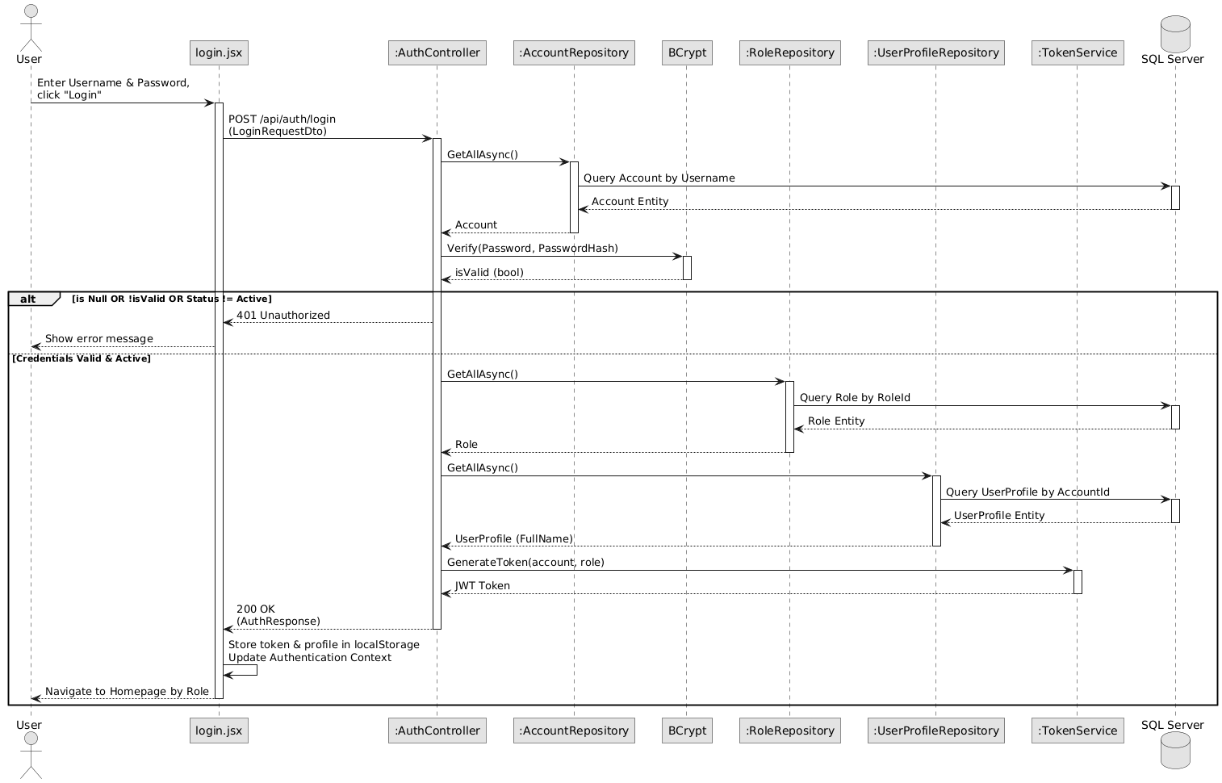
Image 65. Sequence Diagram – Authentication & User Authorization

3.2 Course Syllabus Management
Course management provides the structural foundation for aviation training curricula conforming to CAAV/ICAO frameworks. The involved classes are: CoursesController (exposing POST /api/Courses restricted to Academic Staff and Admin roles), ICourseService / CourseService (handling business logic, duplicate code validation, and syllabus version tracking), CourseRepository (persisting course entities with total planned theoretical and flight hours), and AuditLogRepository (recording course creation events with an immutable audit entry). CourseManagement.jsx provides the administrative interface for Academic Staff to configure course metadata, credit weightings, and regulatory syllabus codes.

3.2.1 Class Diagram
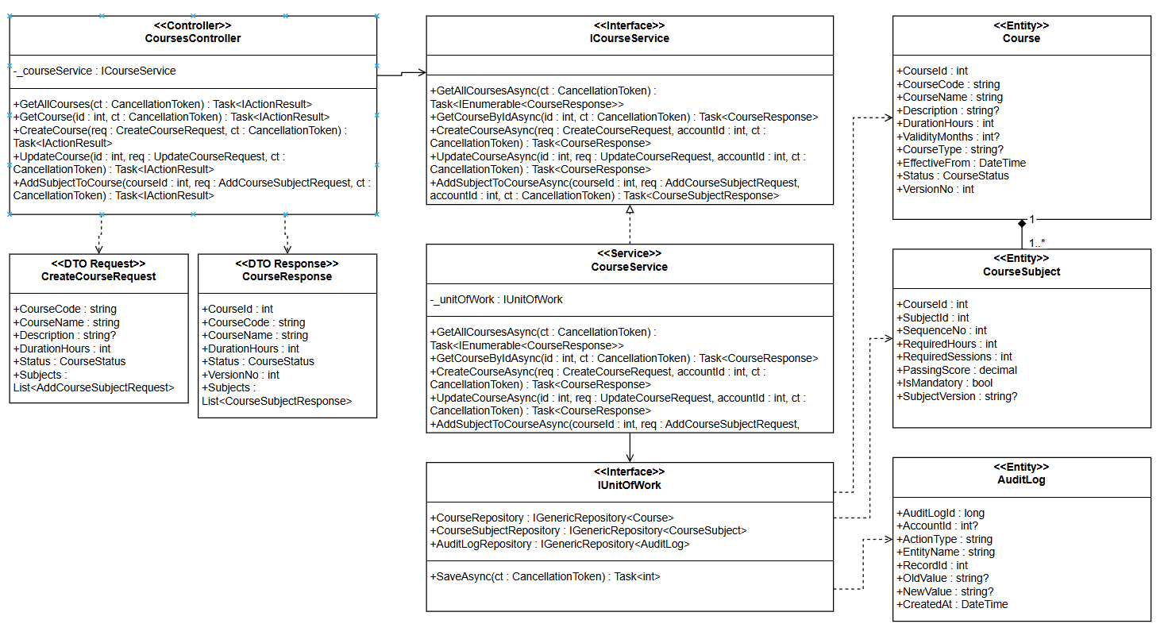
Image 65. Class Diagram – Course Syllabus Management

3.2.2 Sequence Diagram
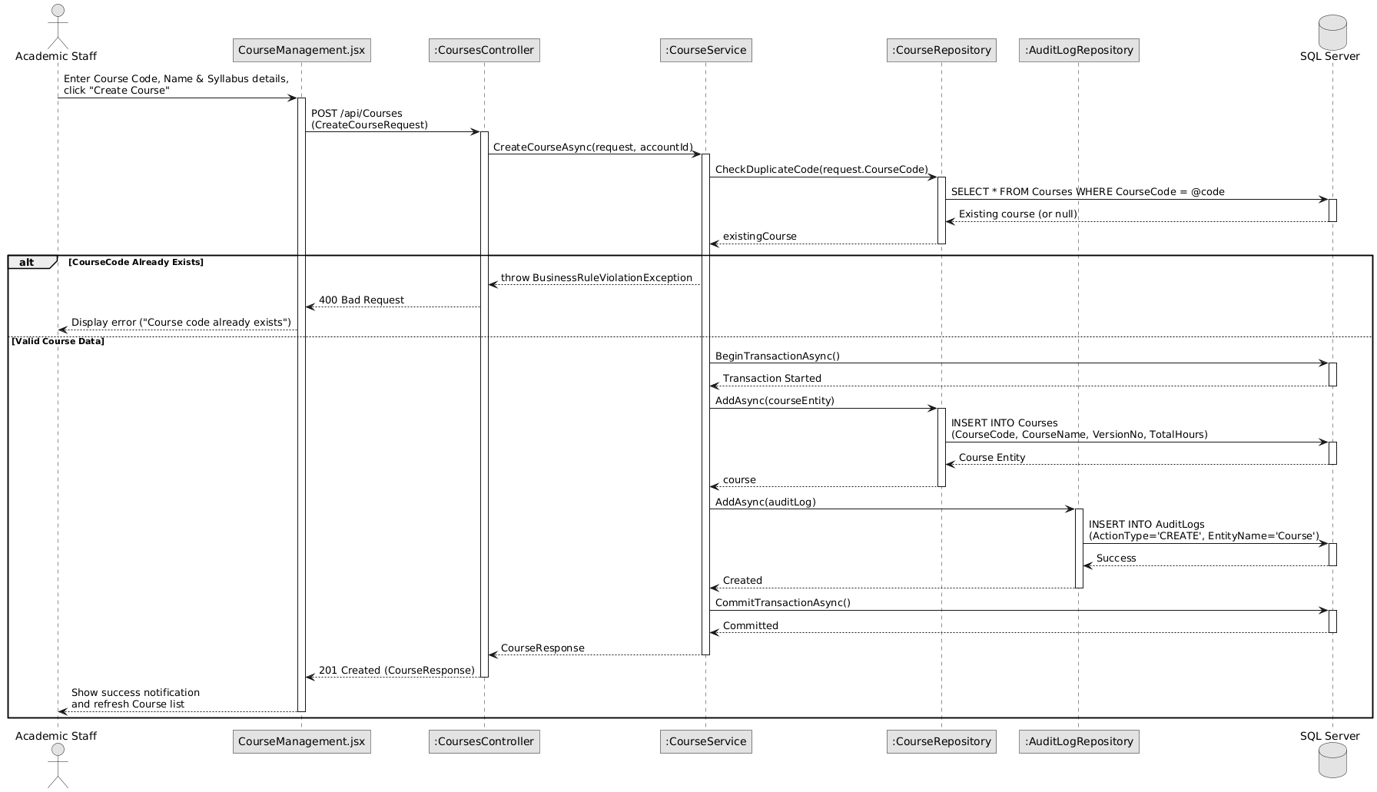
Image 66. Sequence Diagram – Course Syllabus Management

3.3 Subject Module Configuration
Subject configuration defines individual theoretical and practical modules attached to training courses. The involved classes are: SubjectsController (exposing POST /api/Subjects for Academic Staff and Training Managers), ISubjectService / SubjectService (validating unique subject codes within the syllabus and enforcing standard passing thresholds, typically 75%), SubjectRepository (storing theoretical/simulator hours and grading schemas), and AuditLogRepository (tracking curriculum additions). On the client side, SubjectModal.jsx allows academic officers to define subject codes, titles, allocated flight/ground hours, and mandatory completion criteria.

3.3.1 Class Diagram
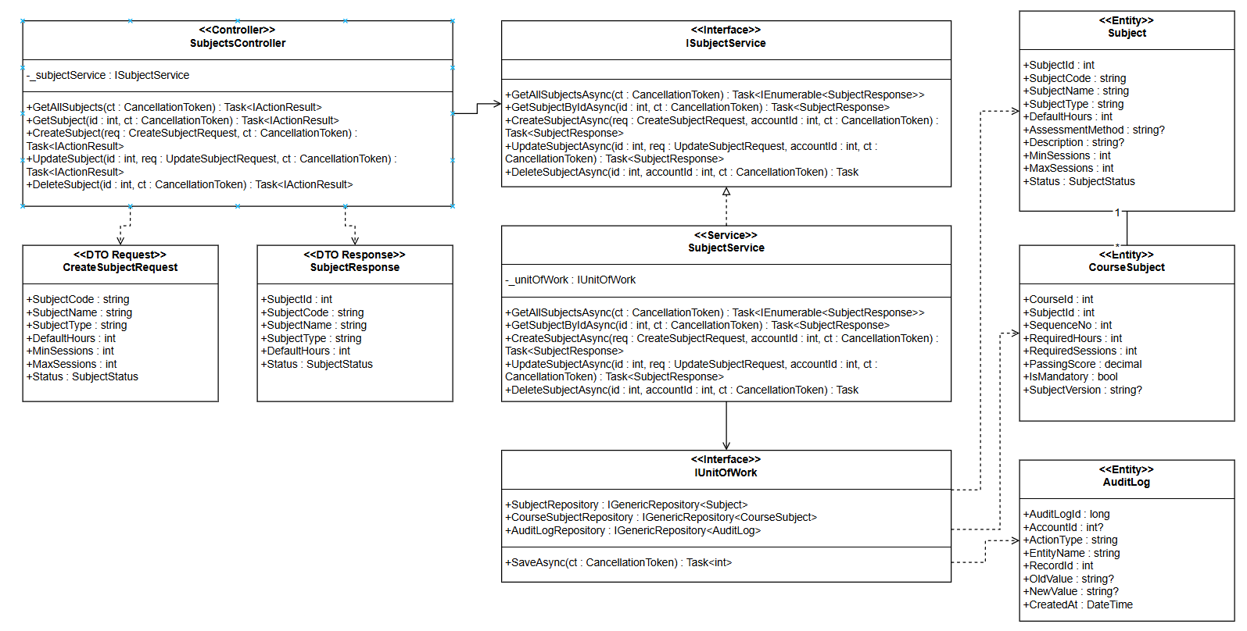
Image 67. Class Diagram – Subject Module Configuration

3.3.2 Sequence Diagram
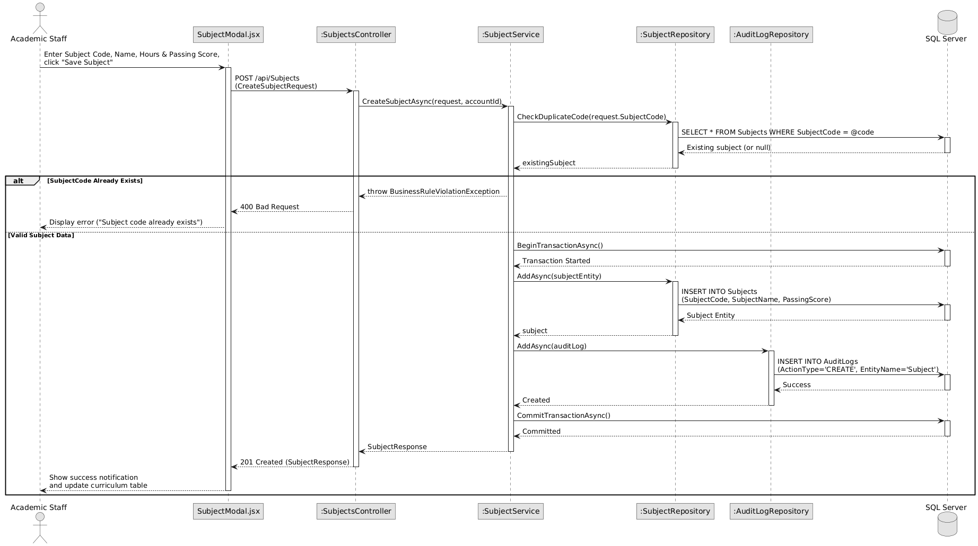
Image 68. Sequence Diagram – Subject Module Configuration

3.4 Class Cohort Scheduling
Class scheduling establishes physical training cohorts delivering structured courses for student groups. The involved classes are: ClassesController (exposing POST /api/Classes), IClassService / ClassService (verifying active course syllabus availability, validating cohort date ranges, and checking code uniqueness), CourseRepository (ensuring parent course validity), ClassRepository (persisting cohort records with planned capacity and operational status), and AuditLogRepository (logging class creation). Through ClassManagement.jsx, Academic Staff initialize class cohorts, assign academic schedules, and define start and expected graduation timelines.

3.4.1 Class Diagram
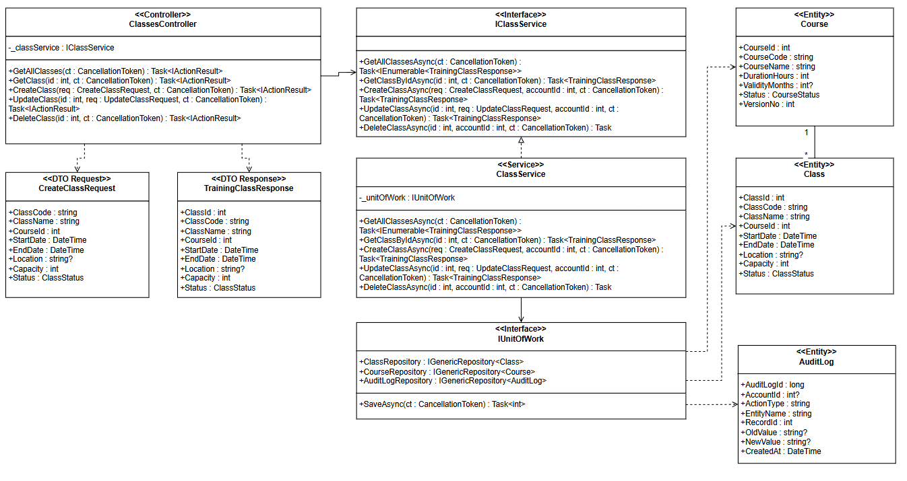

Image 69. Class Diagram – Class Cohort Scheduling

3.4.2 Sequence Diagram
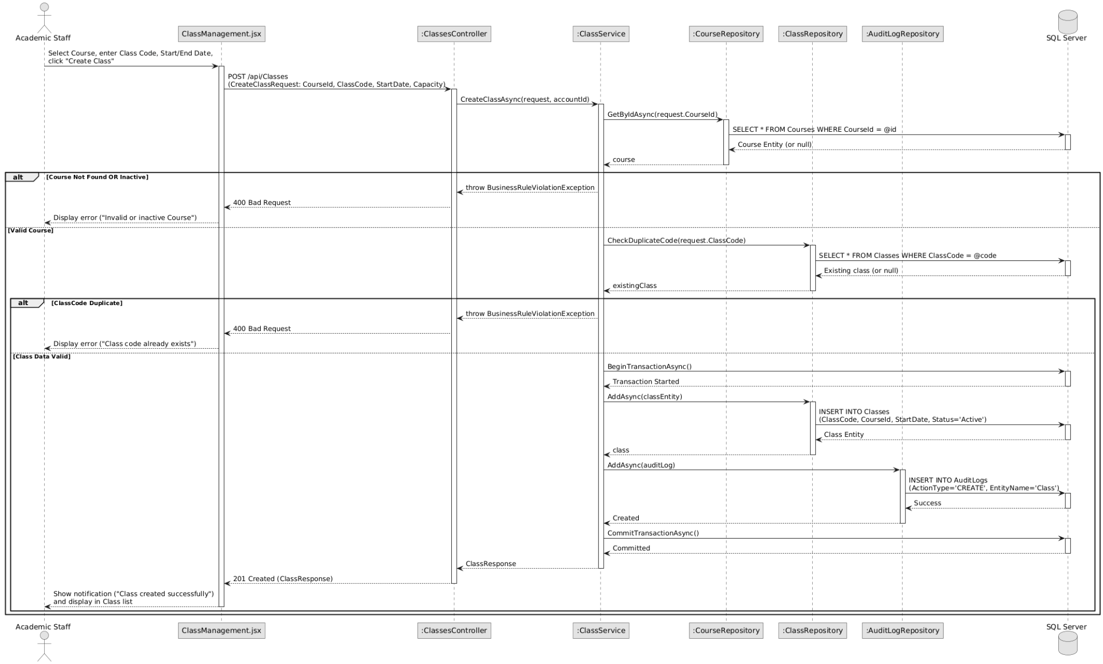
Image 70. Sequence Diagram – Class Cohort Scheduling

3.4.3 State Diagram
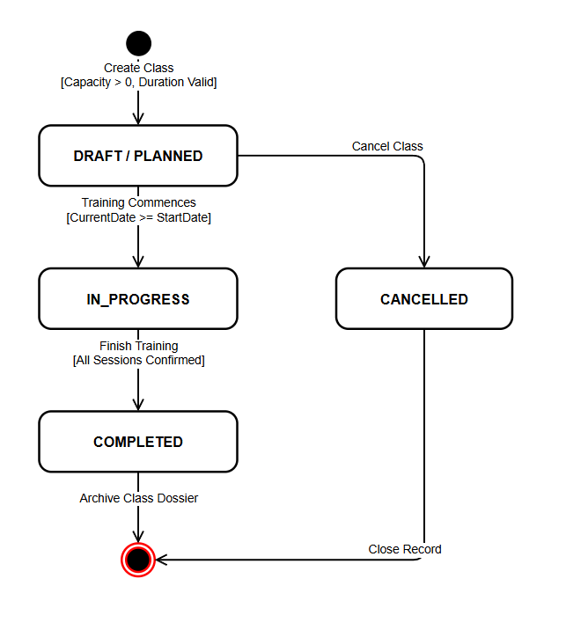
Image 71. State Diagram – Class Cohort Lifecycle

3.5 Student Course Enrollment & ETR Auto-provisioning
Course enrollment formally registers students into active training cohorts and initializes their Electronic Training Record dossiers. The involved classes are: EnrollmentsController (exposing POST /api/Enrollments), IEnrollmentService / EnrollmentService (orchestrating transactional provisioning), ClassRepository (verifying cohort capacity limits and active class status), CourseEnrollmentRepository (storing student-class associations), ETRCourseRecordRepository (automatically generating an initialized ETR dossier directly in InProgress status), and SubjectResultRepository (generating placeholder result records for all mandatory subjects defined in the course curriculum). EnrollStudentModal.jsx enables Academic Staff to enroll qualified students, triggering automatic multi-table provisioning within a single database transaction.

3.5.1 Class Diagram

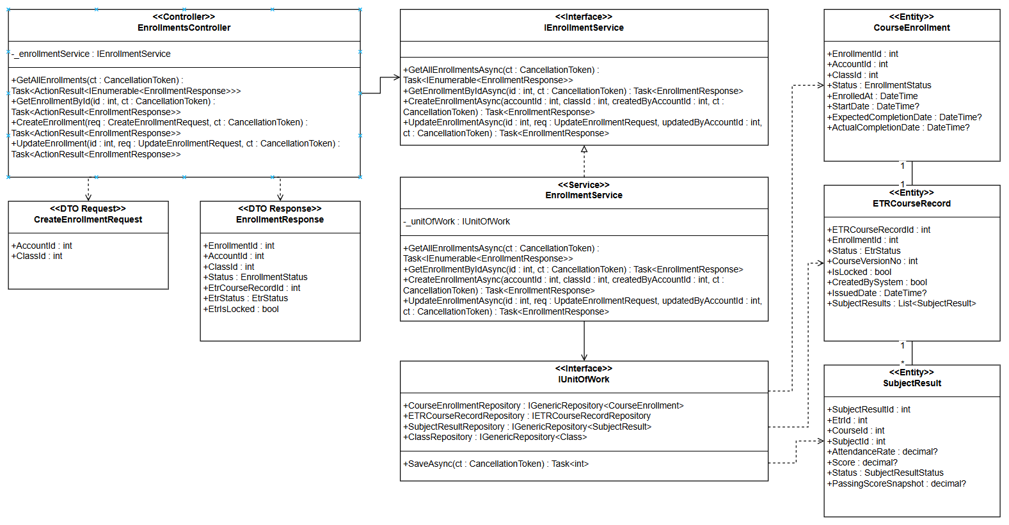
Image 72. Class Diagram – Student Course Enrollment & ETR Auto-provisioning

3.5.2 Sequence Diagram
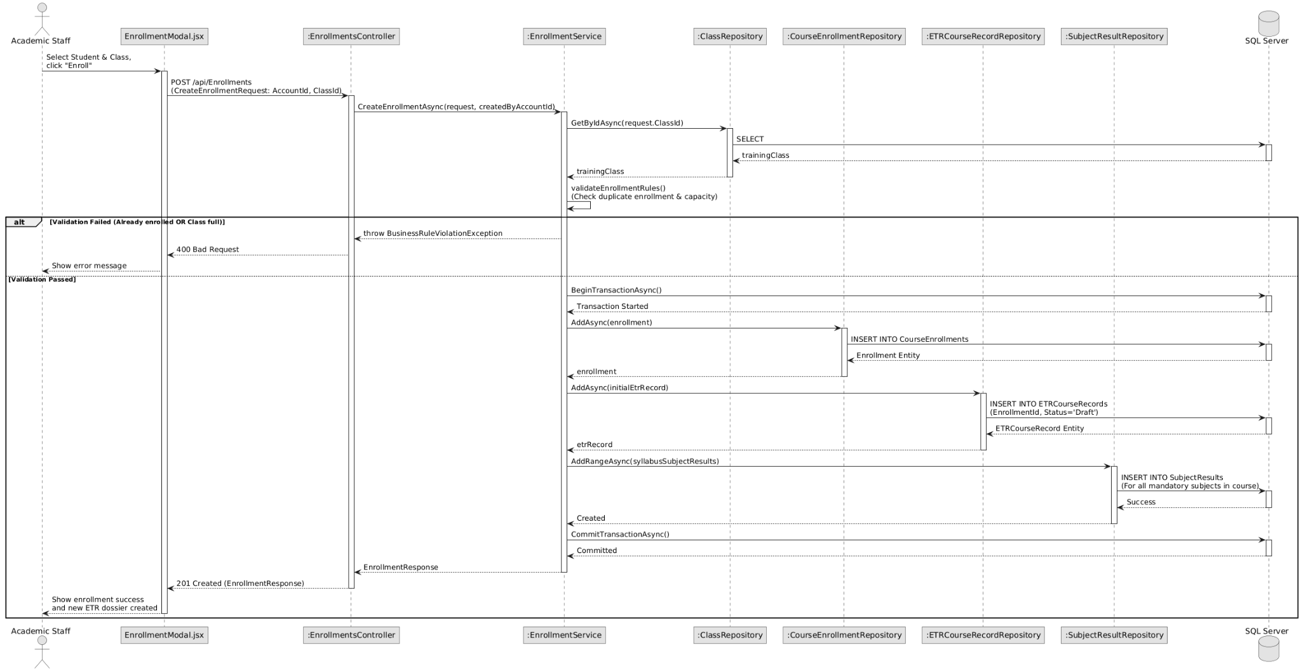
Image 73. Sequence Diagram – Student Course Enrollment & ETR Auto-provisioning

3.5.3 State Diagram
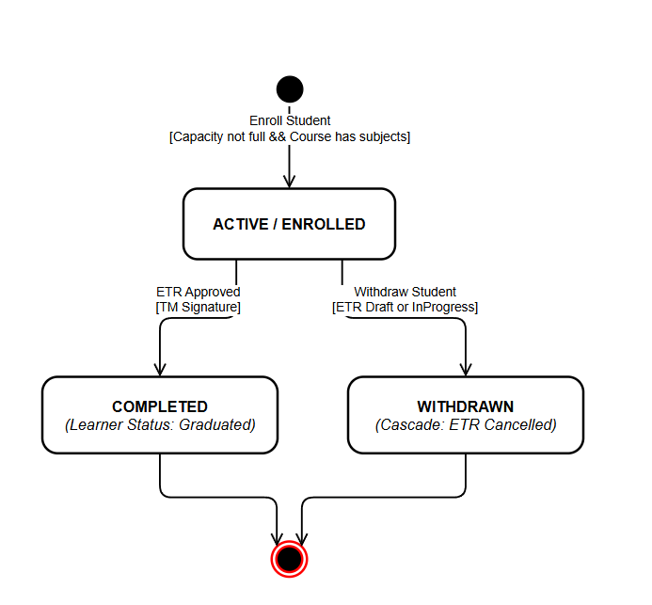
Image 74. State Diagram – Course Enrollment Lifecycle

3.6 Session Attendance Recording & Rate Recalculation
Attendance tracking monitors student participation across scheduled lectures and flight sorties to ensure minimum regulatory presence. The involved classes are: AttendanceController (exposing POST /api/Attendance/record), IAttendanceService / AttendanceService (enforcing session ownership validation so instructors can only record attendance for assigned classes), AttendanceRepository (logging student attendance statuses: Present, Absent, Excused), and SubjectResultRepository (automatically recalculating and updating the student's cumulative AttendanceRate percentage for the associated subject). InstructorAttendance.jsx allows instructors to mark attendance matrices, providing real-time warnings if a student's attendance falls below the mandatory 80% regulatory threshold.

3.6.1 Class Diagram
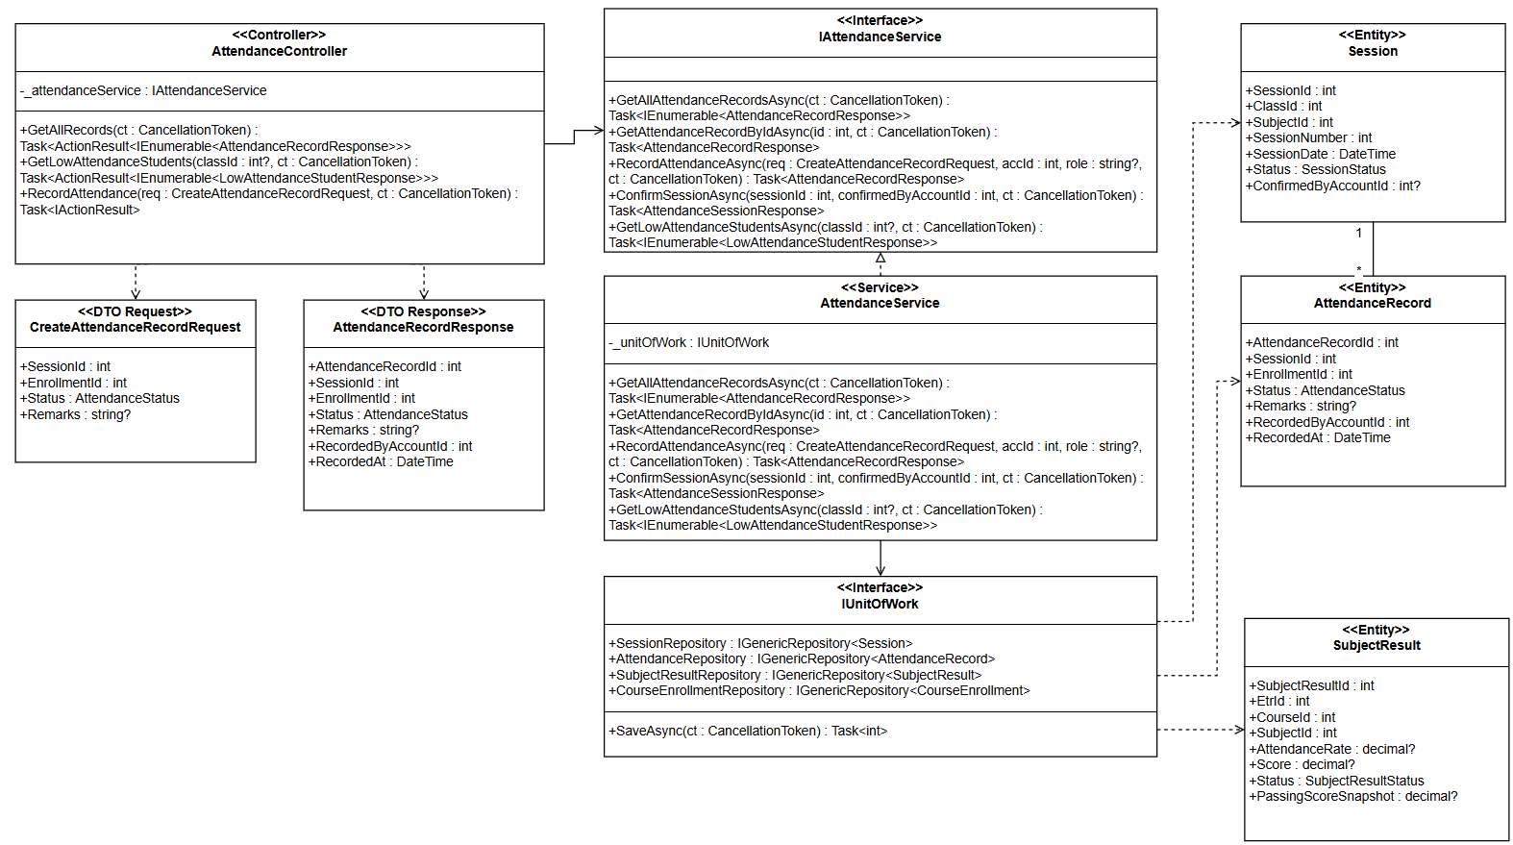
Image 75. Class Diagram – Session Attendance Recording & Rate Recalculation

3.6.2 Sequence Diagram
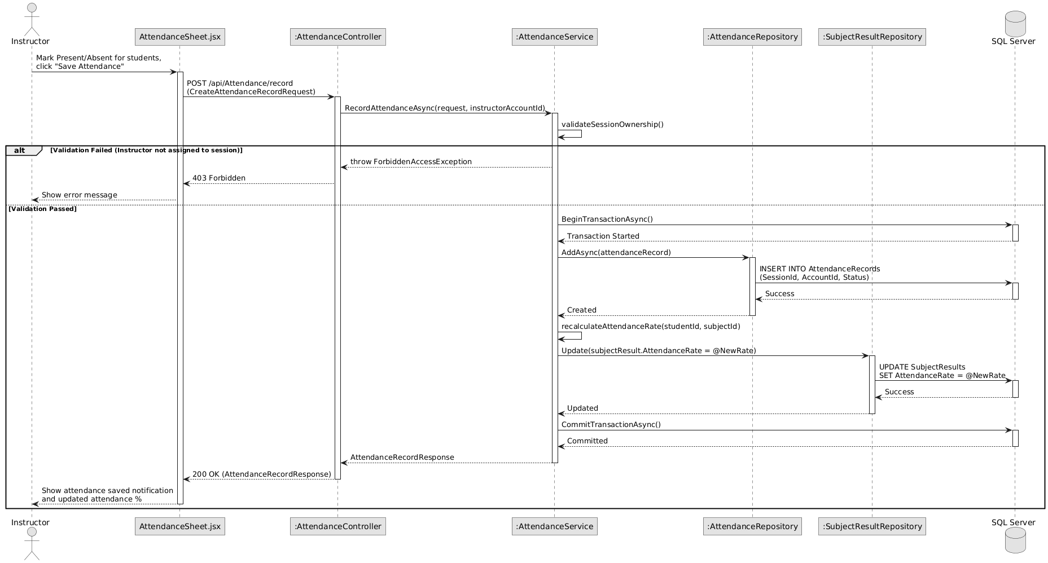
Image 76. Sequence Diagram – Session Attendance Recording & Rate Recalculation

3.7 Assessment Score Recording & Progress Evaluation
Assessment grading records performance evaluations for theoretical examinations and flight tests. The involved classes are: AssessmentResultsController (exposing POST /api/AssessmentResults/record), IAssessmentResultService / AssessmentResultService (managing evaluation workflows within a database execution strategy), ClassOwnershipValidator (verifying that the instructor is formally assigned to the subject in ClassSubjectRepository), AssessmentRepository (retrieving passing thresholds and component weights), AssessmentResultRepository (persisting raw scores, attempt counts, and pass/fail verdicts), and SubjectResultRepository (triggering automatic score recalculation). InstructorAssessments.jsx captures instructor score inputs and remarks, updating the grade roster and triggering audit logs.

3.7.1 Class Diagram
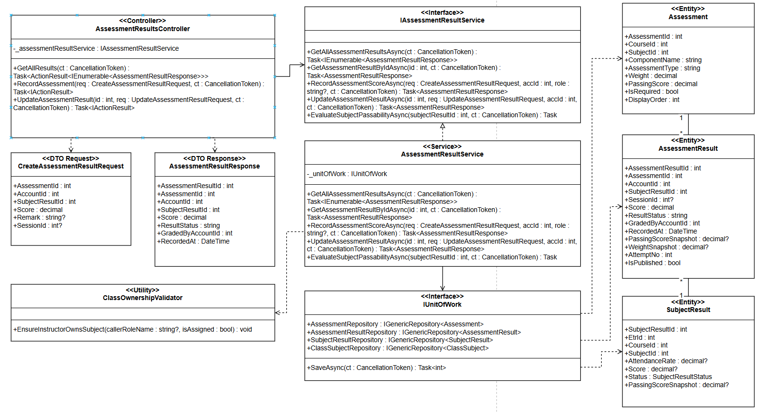
Image 77. Class Diagram – Assessment Score Recording & Progress Evaluation

3.7.2 Sequence Diagram
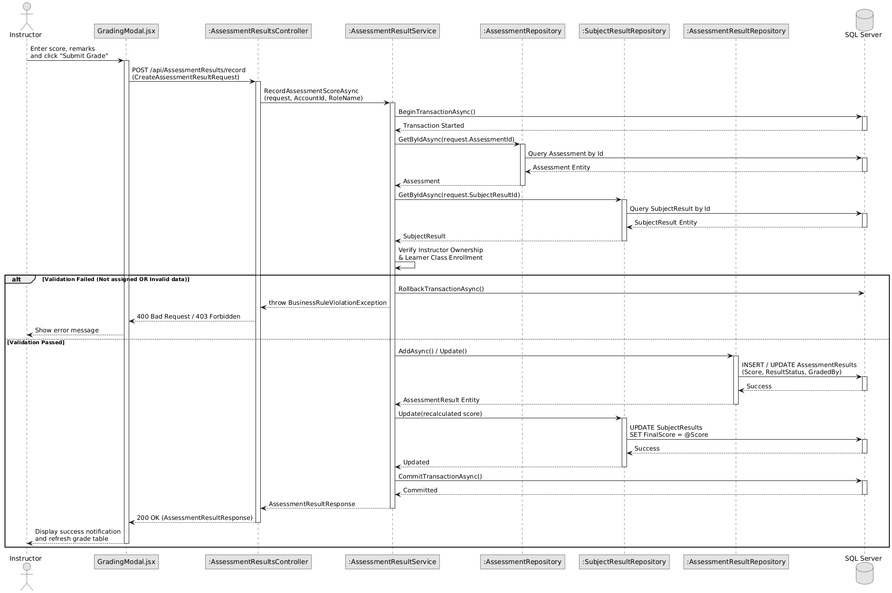
Image 78. Sequence Diagram – Assessment Score Recording & Progress Evaluation

3.8 Practical Checklist Competency Evaluation
Practical checklist evaluation assesses flight simulator sorties and flight maneuvers against standardized competency criteria. The involved classes are: PracticalChecklistResultsController (exposing POST /api/PracticalChecklistResults/record), IPracticalChecklistResultService / PracticalChecklistResultService (validating examiner credentials and checklist task prerequisites), PracticalChecklistResultRepository (recording itemized proficiency ratings such as Satisfactory or Unsatisfactory), and AuditLogRepository (logging examiner evaluations). Through ChecklistModal.jsx, flight instructors record competency observations for specific flight maneuvers, satisfying mandatory syllabus checklist items.

3.8.1 Class Diagram
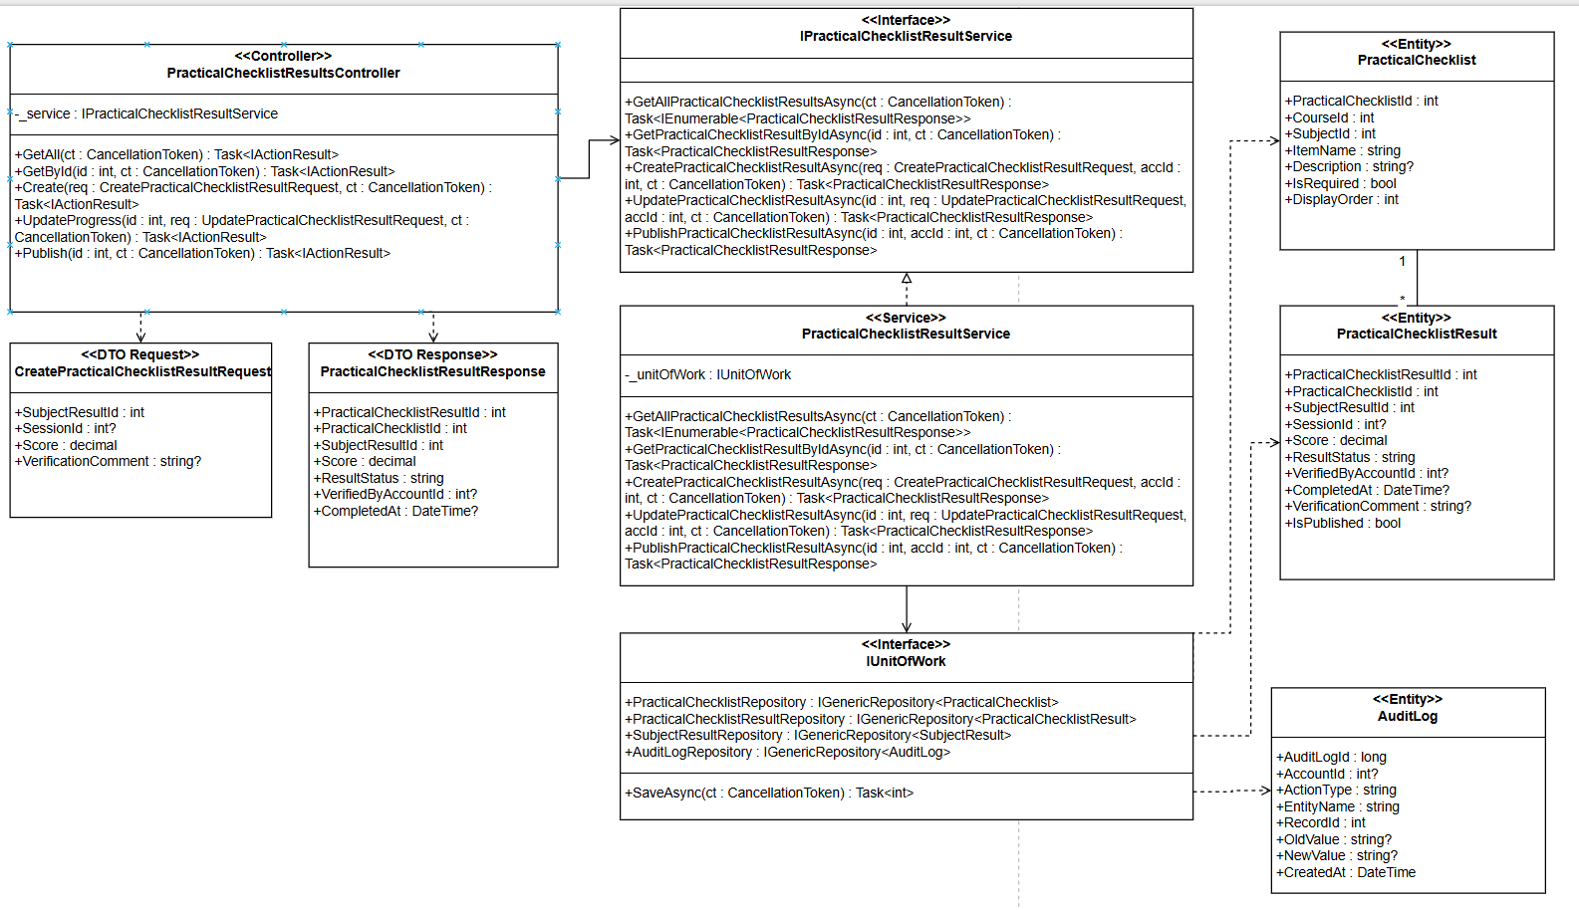
Image 79. Class Diagram – Practical Checklist Competency Evaluation

3.8.2 Sequence Diagram
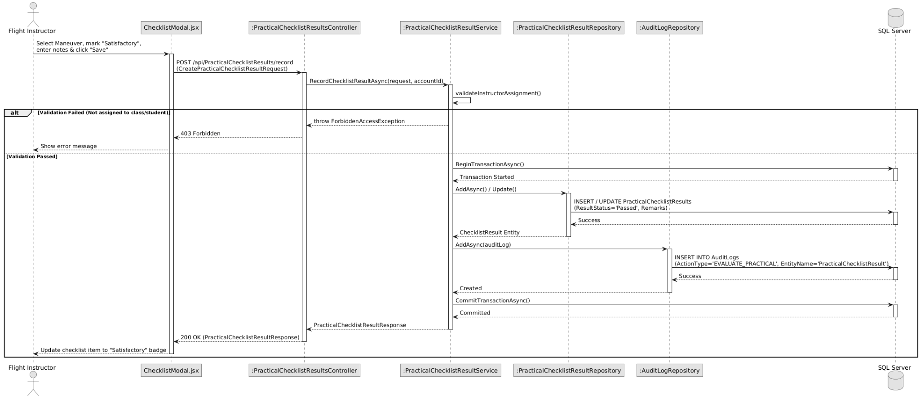
Image 80. Sequence Diagram – Practical Checklist Competency Evaluation

3.9 Compliance Evidence Upload & Integrity Hashing
Evidence management maintains tamper-evident digital proof of student assessments and flight logbook entries. The involved classes are: EvidencesController (exposing POST /api/Evidences accepting multipart/form-data), IEvidenceService / EvidenceService (validating allowed file extensions .pdf, .png, .jpg and file size constraints), IStorageService (persisting binary payloads to physical or cloud storage), EvidenceRepository (persisting file metadata, URLs, and a computed SHA-256 cryptographic hash to prevent unauthorized alteration), and AuditLogRepository (logging evidence uploads). InstructorEvidence.jsx allows instructors and academic staff to attach examination sheets and signed logbook scans directly to subject result records.

3.9.1 Class Diagram
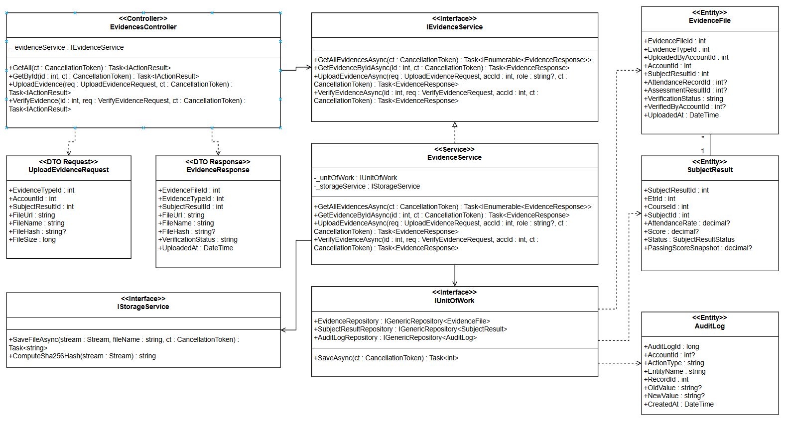
Image 81. Class Diagram – Compliance Evidence Upload & Integrity Hashing

3.9.2 Sequence Diagram
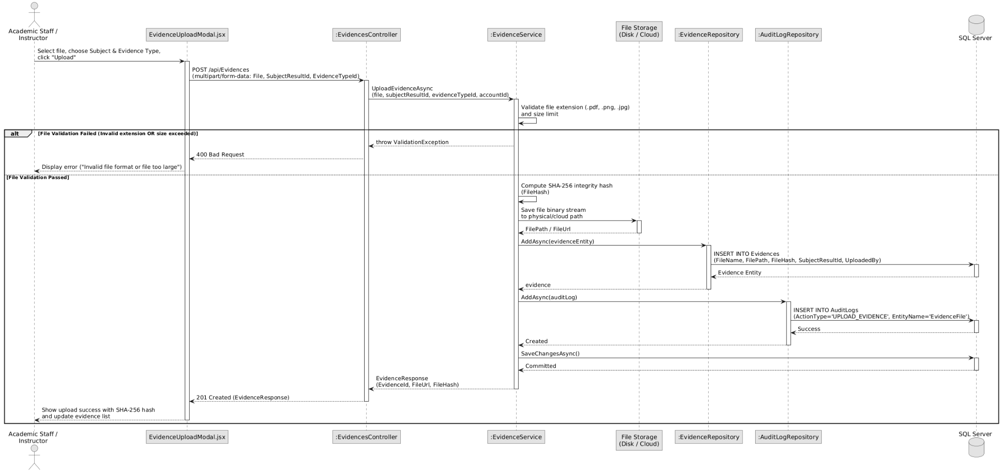
Image 82. Sequence Diagram – Compliance Evidence Upload & Integrity Hashing

3.9.3 State Diagram
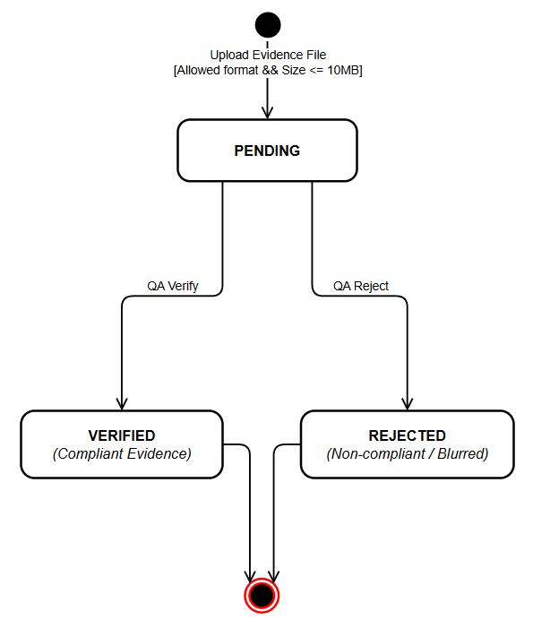
Image 83. State Diagram – Evidence Verification Lifecycle

3.10 Subject Sign-off & Completion Locking
Subject sign-off serves as the formal instructor endorsement locking academic results upon completion of all syllabus requirements. The involved classes are: SubjectSignoffController (exposing POST /api/SubjectSignoff), IAssessmentResultService / AssessmentResultService (enforcing strict prerequisite validations: verifying instructor class assignment, absence of prior active sign-offs, presence of recorded attendance, completion of all course assessments, and evaluation of all mandatory practical checklists), SubjectResultRepository (updating subject status directly to Passed or Failed based on evaluation criteria), SubjectSignoffRepository (creating the digital sign-off endorsement record), and AuditLogRepository (recording the completion event). InstructorAssessments.jsx (via SubjectSignoffModal.jsx) renders the sign-off action, locking input fields against subsequent edits once endorsed.

3.10.1 Class Diagram
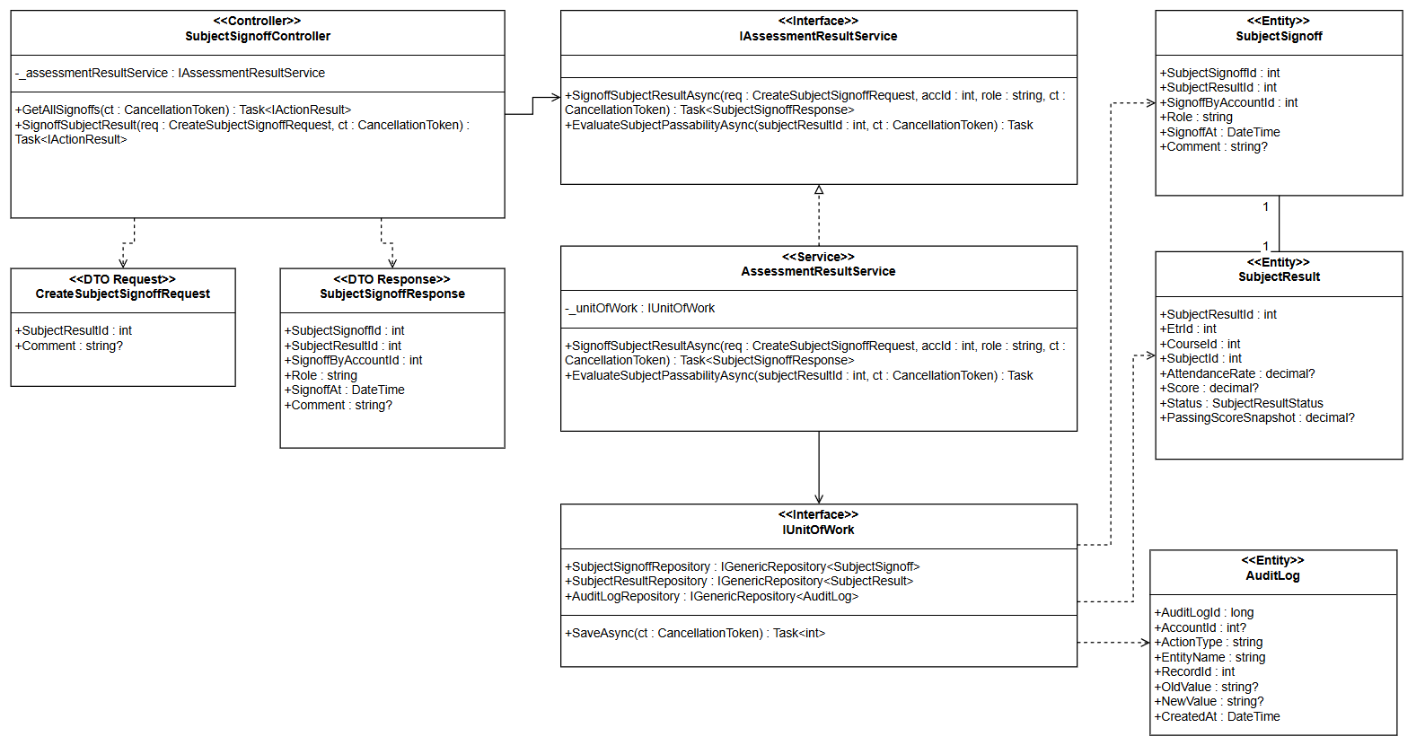
Image 84. Class Diagram – Subject Sign-off & Completion Locking

3.10.2 Sequence Diagram
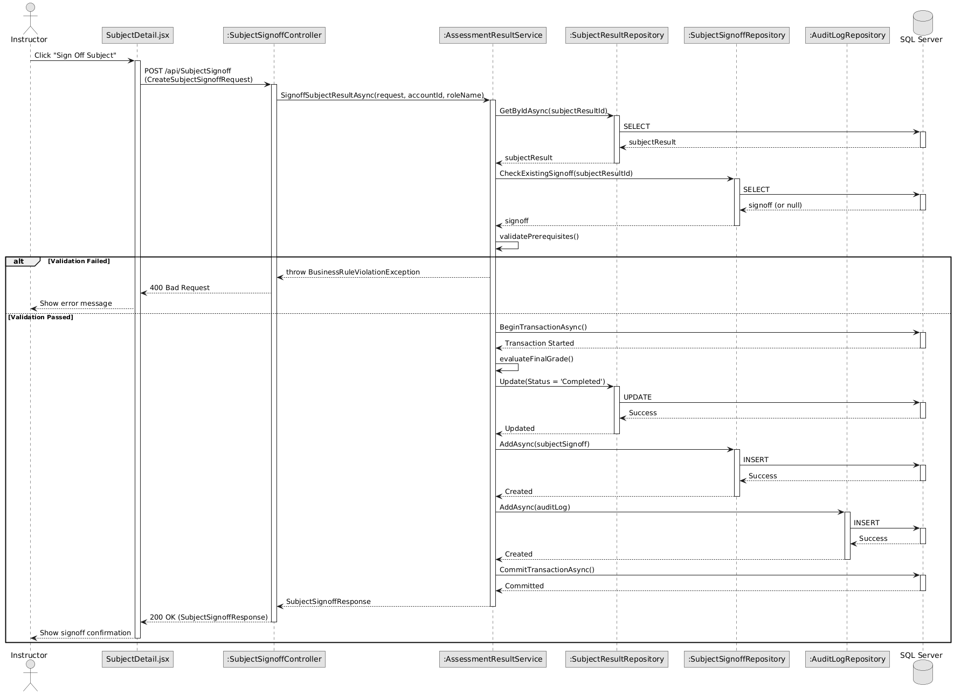
Image 85. Sequence Diagram – Subject Sign-off & Completion Locking

3.10.3 State Diagram
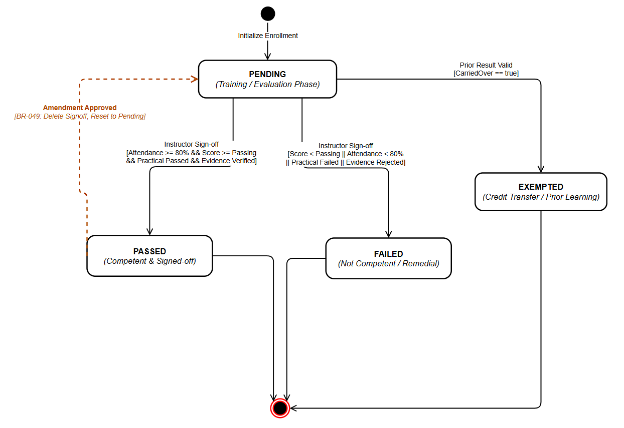
Image 86. State Diagram – Subject Result Lifecycle & Locking

3.11 ETR Dossier Submission for QA Verification
ETR submission initiates the formal regulatory review pipeline once a student fulfills all course completion criteria. The involved classes are: EtrController (exposing POST /api/Etr/{id}/submit), IEtrService / EtrService (executing a comprehensive pre-validation engine: ensuring all mandatory subjects are Passed or Exempted, cumulative attendance meets or exceeds 80%, all attached evidence files are Verified, and all subjects have valid instructor sign-offs), ETRCourseRecordRepository (transitioning record status to Submitted and stamping SubmittedAt), IApprovalService / ApprovalService (automatically provisioning a new ApprovalRequest routed to QA/Training Managers), and AuditLogRepository (logging the dossier submission). EtrDetail.jsx displays the 100% completion progress badge and allows academic staff to dispatch the dossier for institutional review.

3.11.1 Class Diagram

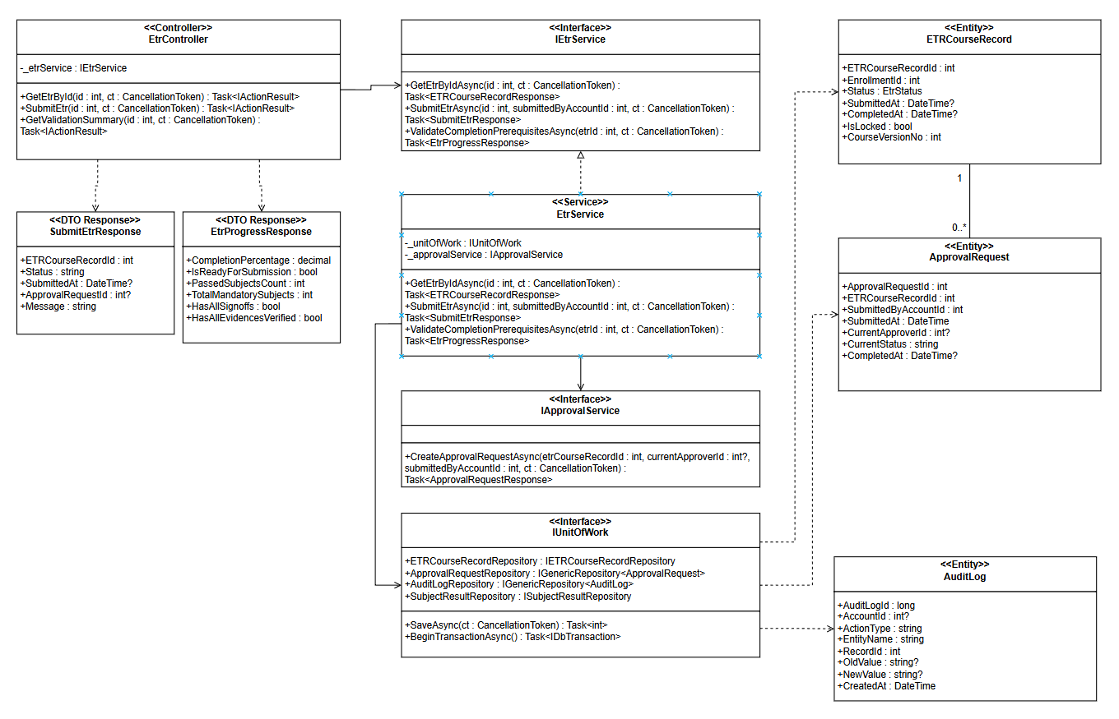
Image 87. Class Diagram – ETR Dossier Submission for QA Verification

3.11.2 Sequence Diagram
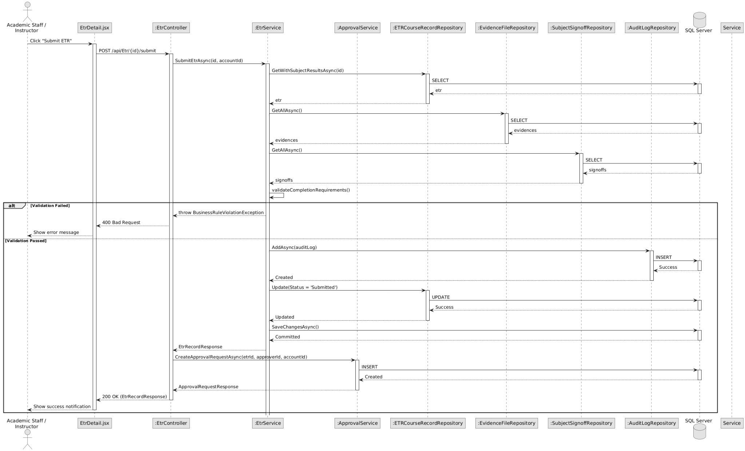
Image 88. Sequence Diagram – ETR Dossier Submission for QA Verification

3.11.3 State Diagram
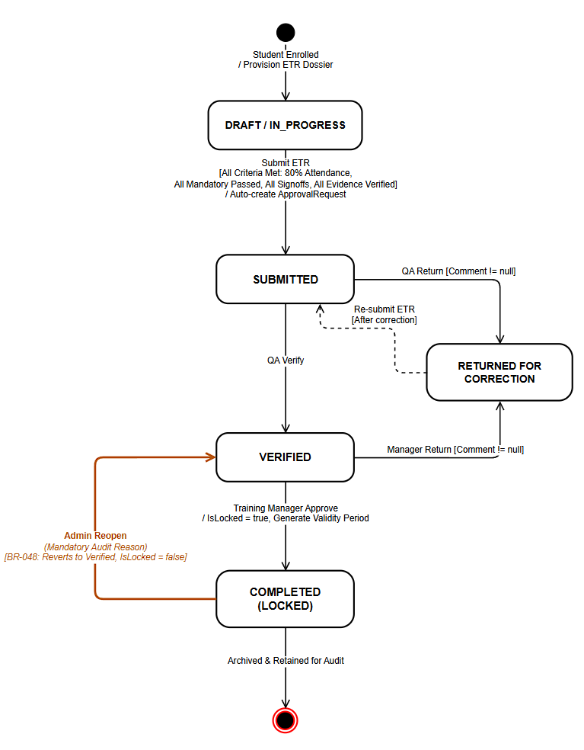
Image 89. State Diagram – ETR Course Record Lifecycle

3.12 ETR Multi-Level Approval Workflow
The approval workflow governs institutional verification and executive sign-off for submitted ETR dossiers with support for corrections. The involved classes are: ApprovalsController (exposing POST /api/Approvals/{id}/process?action=...&comment=...), IApprovalService / ApprovalService (enforcing strict role segregation: QA may Verify or Return, Training Manager may Approve or Return, and mandatory comments are enforced for any Return/Reject decision), ApprovalRequestRepository (updating workflow status to Verified, Approved, or ReturnedForCorrection), ApprovalHistoryRepository (preserving immutable audit trails of reviewer decisions, remarks, and timestamps), ETRCourseRecordRepository (synchronizing dossier state), and AuditLogRepository (logging security audit events). Through EtrApproval.jsx, reviewers evaluate dossiers and either endorse them or return them with specific correction rationale.

3.12.1 Class Diagram
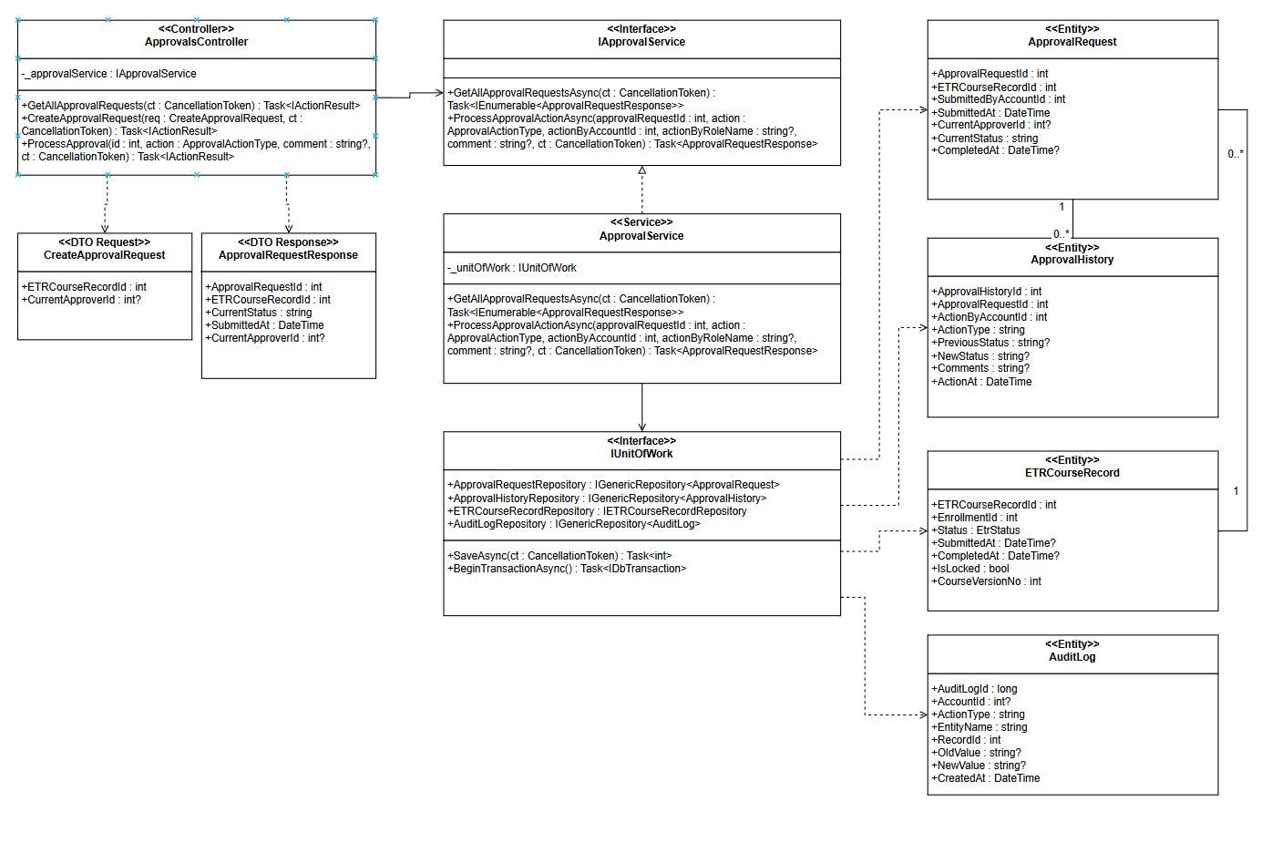
Image 90. Class Diagram – ETR Multi-Level Approval Workflow

3.12.2 Sequence Diagram

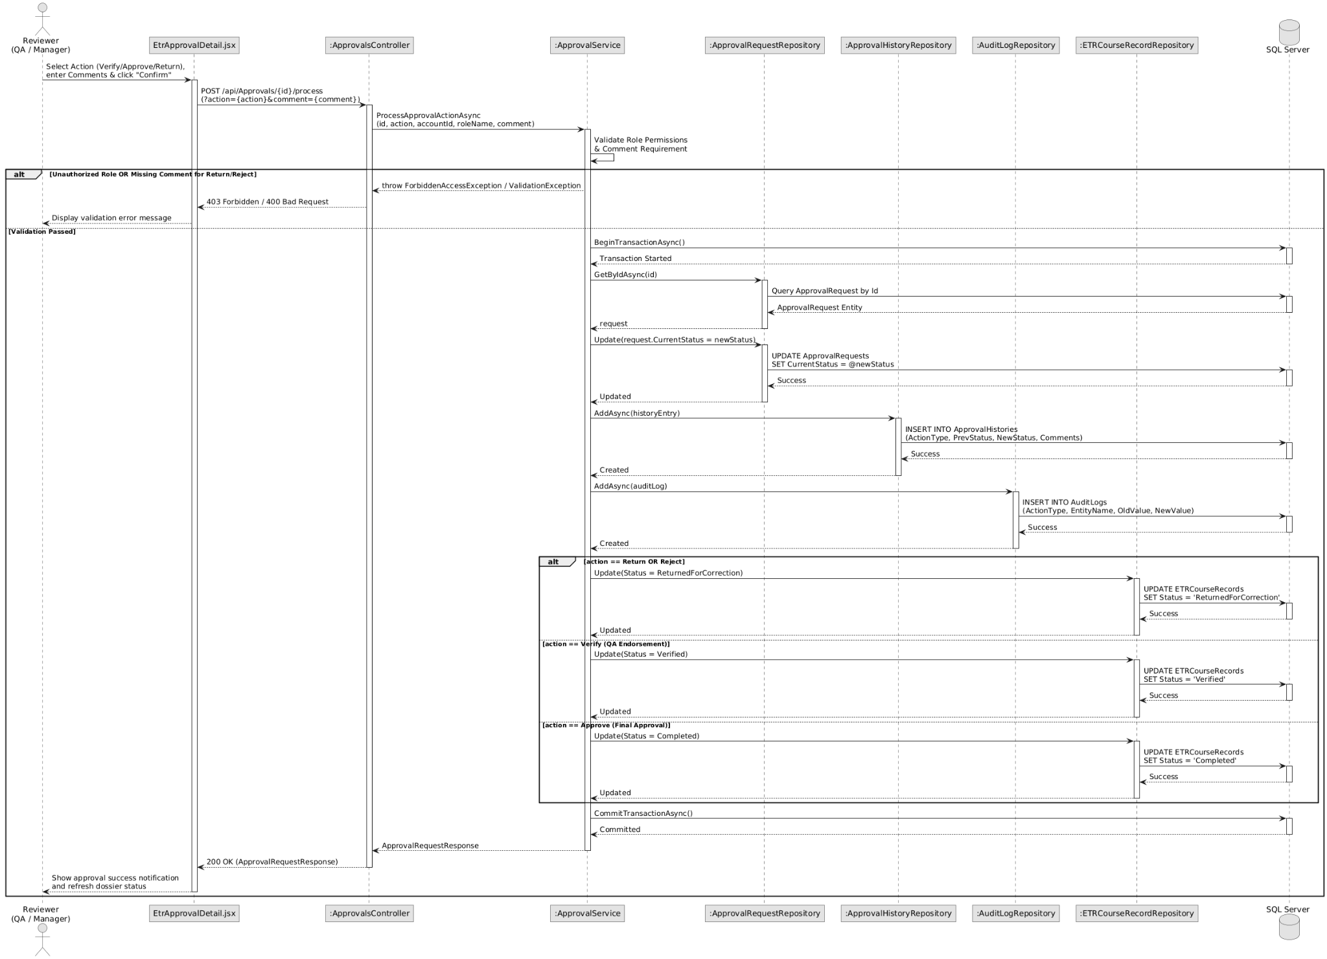
Image 91. Sequence Diagram – ETR Multi-Level Approval Workflow

3.12.3 State Diagram
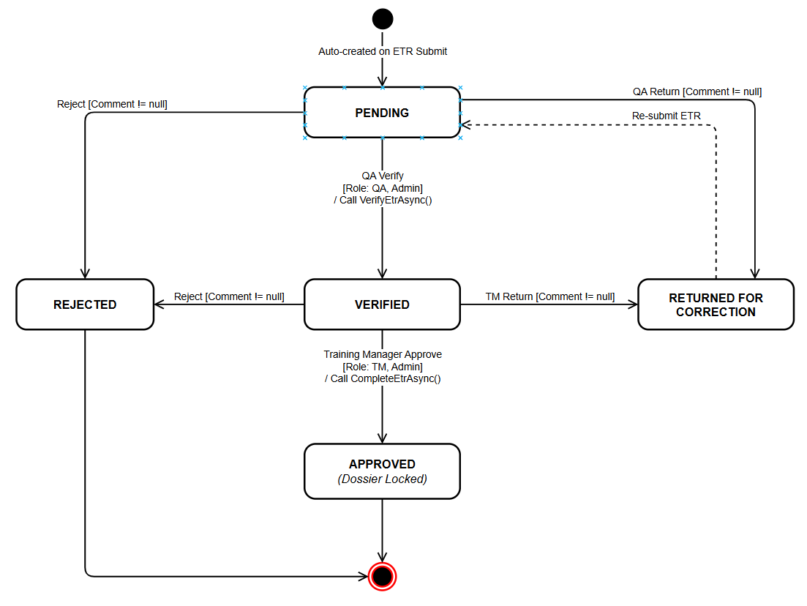
Image 92. State Diagram – Approval Request Workflow

3.13 Post-Signoff Amendment & Subject Unlock
The amendment workflow provides a strictly controlled mechanism to reopen signed-off subject results when corrections are justified. The involved classes are: SubjectSignoffController (initiating POST /api/SubjectSignoff/{id}/unlock-request), AmendmentsController (exposing POST /api/Amendments/{id}/approve restricted to Training Managers and Administrators), IAmendmentService / AmendmentService (verifying that the amendment is pending and that the parent ETR is not locked/completed), SubjectResultRepository (resetting subject status back to Pending to enable instructor re-grading), SubjectSignoffRepository (soft-deleting previous sign-off endorsements to mandate a fresh sign-off after correction), AmendmentRequestRepository (recording manager approval and comments), and AuditLogRepository (logging an AMENDMENT_APPROVE audit entry). TrainingManagerAmendments.jsx enables Training Managers to inspect amendment rationales and authorize unlock operations.

3.13.1 Class Diagram
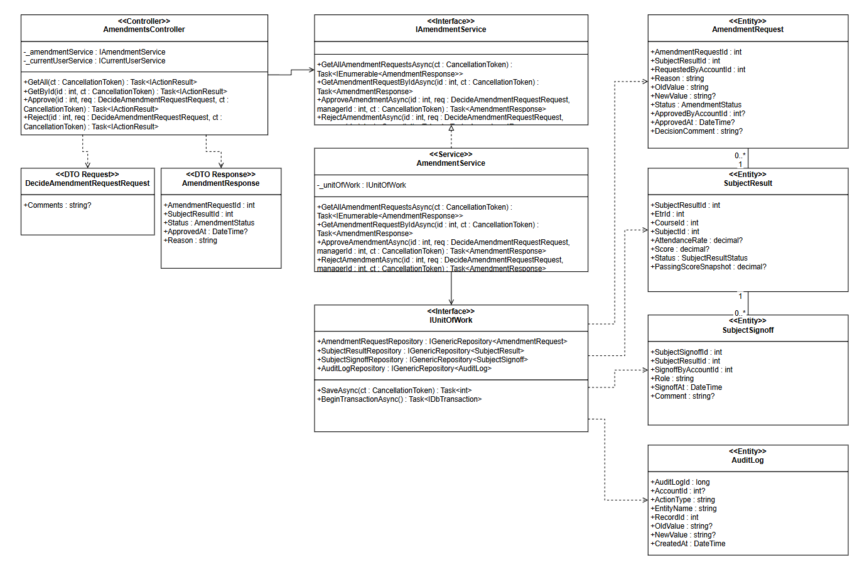
Image 93. Class Diagram – Post-Signoff Amendment & Subject Unlock

3.13.2 Sequence Diagram
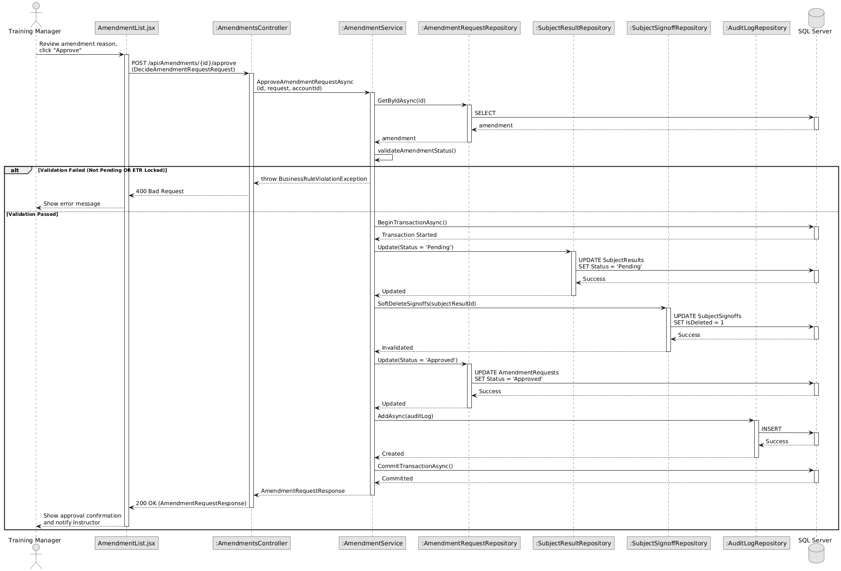
Image 94. Sequence Diagram – Post-Signoff Amendment & Subject Unlock

3.13.3 State Diagram
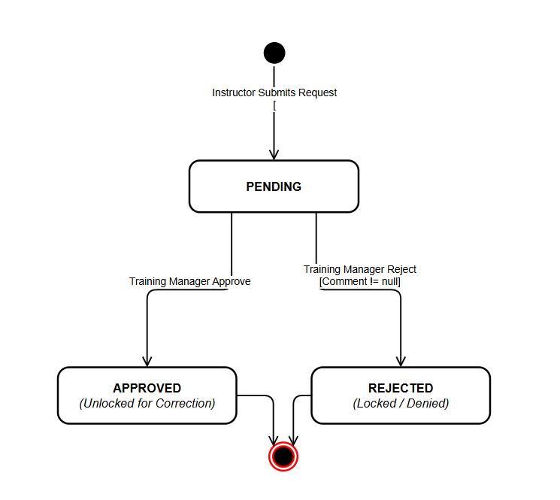
Image 95. State Diagram – Amendment Request Lifecycle

